**Licking County Housing Development Affordable Housing**

The Licking County Housing Affordability project is undertaken by the Real Estate team. The project's primary focus is to determine the demographic group most affected by the issue of Housing Affordability and identify the factors that contribute to this problem.

**Motivation**

By collecting and analyzing data, we aim to equip our client, the Licking County Coalition for Housing, with valuable insights that will enable them to better support their community's residents. With this information, the coalition can develop more effective approaches to address the issue of housing affordability, ultimately helping those who need it most.

**Author(s)**

There are four team members who contribute to this project.

Josh Vo - narrow down the scope of project, build the draft idea

Varun - build statistical model & visual for crime rate

Minh - build statistical model & visual for number of bedrooms

Ha - build visualization in general

**Build Status**

As of present, the project has been successfully completed, and no bugs or errors have been detected to our knowledge. Furthermore, we acknowledge that this project has the potential to be expanded upon and developed further in various directions.

**Requirements**

To run the code, users will need to have R software installed on their computer. To use Tableau, users can acces <https://www.tableau.com/> and use the free public version. Additionally, the following packages will need to be installed in R: ggplot2, dplyr, and tidyr. For Tableau, there is no need to install any packages.

**Data and Code Files**

Our complete work is store in this [Google Drive](https://drive.google.com/drive/folders/1q4c551eKL9Sw8gFAY81j37OYA2z85WTk?usp=share_link), including the following components:

1. [Final written report](https://drive.google.com/file/d/1tn47kyyqTYKdj6_Dkh3TOcc5JvMnfqsj/view?usp=share_link)
2. [Readme file](https://docs.google.com/document/d/1yzjyT75eAwFol8D-jOCzcxQE5SirO6Hlzk9DysA4TvE/edit?usp=sharing)
3. [Data Reuse Plan](https://docs.google.com/spreadsheets/d/1GwV0fvvsdjMBUMThlTOutN8ve-2XJtygJIqQlnL1pGQ/edit?usp=share_link)
4. [R file](https://drive.google.com/file/d/1lMKH1rt_mC4SfQ-KJo4wQ3rYc12T3BM_/view?usp=share_link) with the codes for:

* T-test to show the relationship between the rental price in 2019 and 2022 for bedroom units.
* Anova test for the rental price in 2019 and 2022 based on bedrooms units
* Bar plot and point plot comparing the violent crimes and property crimes by County

1. Datasets**:**

| [Bedrooms2019](https://docs.google.com/spreadsheets/d/1qr7D0uh-vgcUC7wEDob1SLuinNhc6oTqByIvPYNsAlc/edit#gid=0) | [Bedrooms2022](https://docs.google.com/spreadsheets/d/1UrlAItrmmCKWqBLryqP_qa5ucPJ2P5HO6MdRU8U6l6Y/edit#gid=0) | [Ohio.xls](https://docs.google.com/spreadsheets/d/1mWuatUtr99MDaXn_c6kumqmoHuNVj-Wu/edit?usp=share_link&ouid=108655431574540749526&rtpof=true&sd=true) |
| --- | --- | --- |

**How to Use?**

A step-by-step guide to access and run the R file (named “*Progress Report.Rmd*”):

1. Download Progress Report.Rmd file and install R studio (<https://posit.co/download/rstudio-desktop/>)
2. Open the progress report file with RStudio
3. There are 5 different code boxes in grey area. Each box represents the statistical test or read the data sets. The information for each line code is provided in each code box, after the #.

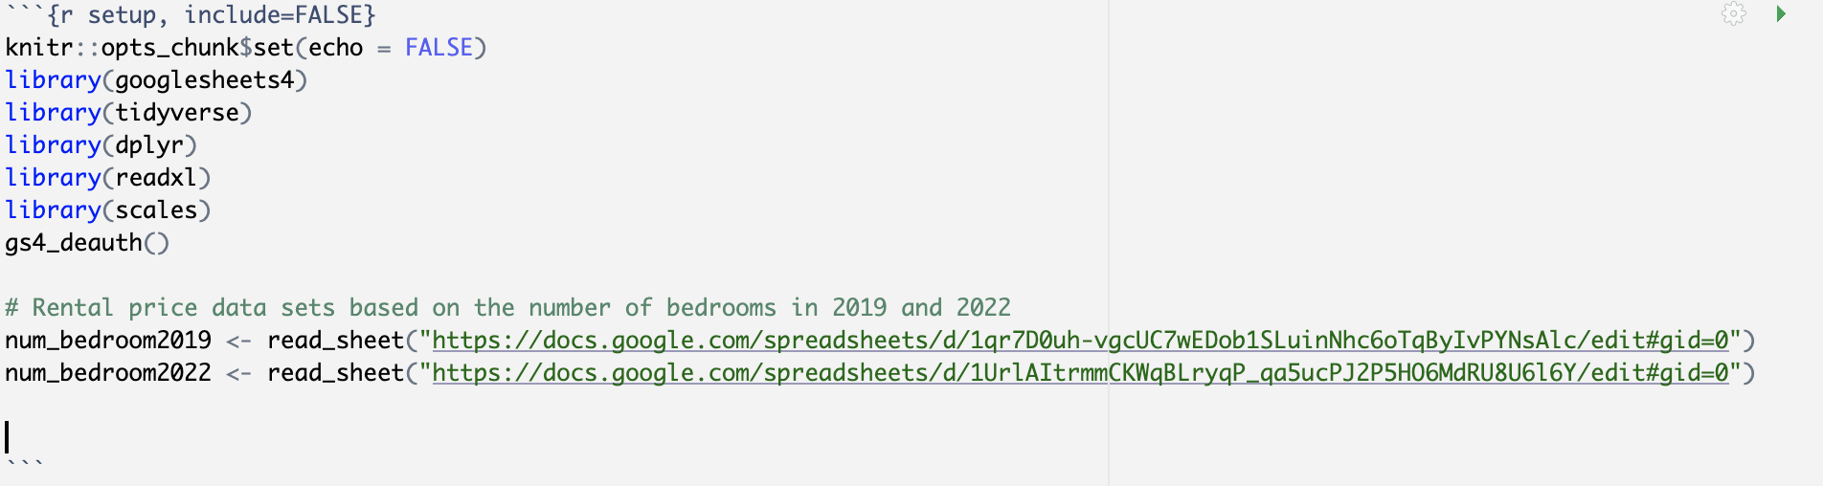

4. In the tool bar, press Run and then Run All to see the results.



**Contribute**

We welcome contributions from interested individuals. To contribute, please fork the project repository and submit a pull request with your changes.

**Credits**

We would like to thank Dr. Supp, our professor, for supporting us in processing this project and creating. Additionally, we really appreciate the support and advice from Deb Tegtmeyer and Trina Woods.

**License**

Open source:

* R studio: Version 2022.12.0+353 (2022.12.0+353) Copyright (C) 2022 by Posit Software, PBC
* Tableau: Patent - http://www.tableau.com/ip ⓒ 2022 Tableau Software, LLC and its licensors. All rights reserved.